Document Number | Fire Alarm Response, Notification, and Impairment D.38.01
Owner/Contact Information: | Dicky Hawks
Effective Date: | 12/12/23
Last Revised/Reviewed: | Final Draft 12/7/23
Related Policies and Procedures | North Carolina State Building Code: Fire Prevention Code 2018  National Fire Protection Association (NFPA) 72: National Fire Alarm and Signaling Code

- Purpose/Introduction
The purpose of these procedures is to ensure life safety by coordinating UNCG’s response to fire alarm events and fire impairment events. The overall goal of these procedures is to ensure that UNCG meets the minimum safety requirements for protecting occupants, buildings, and building contents during fire alarm activations and/or impairment to a fire protection system.

- Definitions
2.1 Fire Alarm System - A system or portion of a system consisting of components and circuits arranged to monitor and annunciate the status of fire alarm or supervisory signal-initiating devices and to initiate the appropriate response to those signals.
2.2 Fire Protection System - Approved devices, equipment, and systems or combinations of systems used to detect a fire, activate an alarm, extinguish or control a fire, control or manage smoke and products of a fire or any combination thereof.

2.3 Impairment - Any condition that would prevent a system from operating as designed or creates an unsafe condition.

2.4 Impairment Coordinator - Person who manages the impairment while system work is being performed. The impairment coordinator shall:
- Ensure compliance with and implementation of the requirements of the Impairment Program.
- Be the contact person for the remainder of the impairment unless another person is designated in writing.

- Procedural Steps

3.1 UNCG Police Department (UNCG PD) Procedures

3.1.1 Fire Alarm

- Dispatch officer to scene/Notify Greensboro Fire Department (GFD) of alarm
- Follow Internal PD protocols
- Verify the state of the fire alarm panel
- Reset panel if clear to do so
- If panel will not reset, Notify Facilities Operations (FO) = Fire Watch Needed

3.1.2 Trouble/Maintenance/Supervisory Alarm Signal

- Dispatch officer to scene
- Follow Internal PD protocols
- Verify the state of the fire alarm panel
- Full Alarm = Notify GFD
- Trouble Single Device = Silence alarm and contact FO = No Fire Watch. Call Facilities Operation (FO) Customer Service Center (CSC) for fire tech during normal business hours or on-call Tech after hours
- Trouble Notification Circuits = Silence alarm and contact FO = Fire Watch Needed. Call CSC for fire tech during normal business hours or on-call Tech after hours
- Trouble Multiple Devices = Silence alarm and contact FO = Fire Watch Needed. Call CSC for fire tech during normal business hours or on-call Tech after hours

3.1.3 Fire Alarms That Are No Longer Reporting to UNCG PD

- Dispatch officer to the scene
- Follow Internal PD protocols
- Verify the state of the fire alarm panel
- Normal Status = Contact FO and inform them alarm is no longer reporting to UNCG PD. FO will notify occupants as described in the impairment section of this document.
- Trouble Single Device = Silence alarm and contact FO = No Fire Watch. FO will notify occupants as described in the impairment section of this document
- Trouble Notification Circuits = Silence alarm and contact FO = Fire Watch Needed
- Trouble Multiple Devices = Silence alarm and contact FO = Fire Watch Needed

3.2 UNCG Fire Alarm Systems Shop Procedures

3.2.1 Minimum Qualifications

According to NFPA 72, persons performing maintenance on fire alarm systems (Fire Alarm Tech) must meet at a minimum the following criteria:
Service personnel shall be qualified and experienced in the inspection, testing and maintenance of systems addressed within the scope of this code. Qualified Personnel shall include, but not be limited to, one or more of the following:
- Personnel who are factory trained and certified for the specific brand of system being serviced.
- Personnel who are certified by a nationally recognized certification organization acceptable to the authority having jurisdiction.
- Personnel who are registered, licensed or certified by a state or local authority to perform service on systems addressed within the scope of this code.
- Personnel who are employed and qualified by a nationally recognized testing laboratory for servicing systems within the scope of this code.
It is recommended that persons responding to or correcting issues with fire alarms hold at a minimum a certification from a reputable certifying agency such as the National Institute for Certification in Engineering Technologies (NICET) Level 2 or work under the direct supervision of someone who is certified.

3.2.2 Full Alarm Signals

- Panel cannot be reset by UNCG PD = Tech shall respond within 1 hour to reset and or evaluate the alarm system (NFPA 72).
- For the period between UNCG PD response and arrival of the fire alarm tech, a fire watch shall be instituted. In unoccupied buildings, the fire watch may be delayed until the fire alarm tech arrives.

3.2.3 Trouble/Maintenance/Supervisory Alarm Signal

- Trouble Single Device = Tech shall respond to the trouble within 1 hour of notification. (NFPA 72). No Fire Watch Required.
- Trouble Notification Circuits = Tech shall respond to trouble within 1 hour of notification. Fire Watch Required.
- Trouble Multiple Devices = Tech shall respond to the trouble within 1 hour of notification. Fire Watch Required.

3.2.4 Fire Alarms that are no longer reporting to UNCG PD

- Normal Panel and Not Reporting to UNCG PD = Tech shall respond within 1 hour to address the system. No Fire Watch Required. Tech shall notify building occupants per impairment section of this document.
- Trouble Single Device and Not Reporting to UNCG PD = Tech shall respond to the trouble within 1 hour of notification. Tech shall notify building occupants per impairment section of this document.
- Trouble Notification Circuits = Tech shall respond to trouble within 1 hour of notification. Fire Watch Required.
- Trouble Multiple Devices and Not Reporting to PD = Tech shall respond to the trouble within 1 hour of notification. Fire Watch Required.

3.3 Fire Protection System Impairment Procedures

3.3.1 This procedure outlines the requirements that shall be followed in order to disable a fire
protection system (i.e. sprinkler systems, gaseous extinguishing systems, fire alarm systems etc.) or parts of that system, as well as the requirements for a manual fire watch while the system is offline in any University building while it is occupied. A manual fire watch allows for buildings to be temporarily occupied when the above-mentioned systems or portions thereof are out of service.

3.3.2 Complete Fire Watch Implementation Checklist (4.1) and Fire Watch Log (4.2).

3.3.3 In general, any employee/contractor with cause may request to have a fire protection system impaired through Facilities Operations, Housing and Residence Life, or Facilities Design and Construction Department. Only authorized UNCG personnel may impair or restore active fire protection systems. These procedures do not apply to buildings that are unoccupied and under the control of a contractor.

3.3.4 Fire Suppression Systems for cooking appliances that have discharged or activated due to fire do not require a Fire Watch. The cooking appliance shall be taken out of service and use discontinued until system is recharged. Signage to indicate device out of service shall be posted (ie. Lock-out/tag-out).

3.3.5 Levels/Types of Impairment

- Level 1 – Planned or Emergency = A single device in the field (i.e. smoke detector, heat detector) is in trouble or found to be defective. No notification is required.
- Level 2 – Planned or Emergency = A Fire Protection System is operational with an issue reporting to UNCG PD. Notification is required if condition is thought to exist over a period of 2 hours or more. An UNCG Environmental, Health, and Safety (EHS) Impairment Notification Form shall be completed at the following address: https://safety.uncg.edu/resources/forms-reports-links/ (see 4.4 below for example of Google form). No Fire Watch Required. Although a fire watch is not required, steps for notifying UNCG PD shall be taken as described below.
- Level 3 – Planned = Multiple devices or a single booster panel or notification circuit are to be impaired or taken out of service for a period greater than 2 hours. The UNCG EHS Impairment Notification Form shall be completed. Fire Watch Required.
- Emergency - Multiple devices or a notification circuit are in trouble or found to be in trouble or defective. Fire Watch Required. UNCG EHS Impairment Notification Form shall be completed.
- Level 4 – Planned or Emergency = An entire fire alarm or sprinkler system is to be out of service or found to be impaired. Fire Watch Required. UNCG EHS Impairment Notification Form shall be completed.
- Level 5 – Construction Contractor Driven Impairments = Any portion of fire alarm or sprinkler system is impaired as part of a contractor-led construction project in a UNCG occupied building. Fire Watch may be required based on type of impairment listed in Level 1 through Level 4. The UNCG EHS Impairment Notification Form shall be completed. Buildings under contractor control are not included in the scope of this document.

3.3.6 Response to Impairments

3.3.6.1 Level 1- Planned or emergency where a single device is in trouble or out of service.

- No notification required.
- The shop shall respond to the trouble within 1 hour of notification. (NFPA 72).

3.3.6.2 Level 2 –Planned or Emergency = Fire Protection System is operational with issue communicating with UNCG PD.

- Designate an Impairment Coordinator.
- Impairment Coordinator shall ensure the following:
    - Complete UNCG EHS Impairment Notification Form at the following address: https://safety.uncg.edu/resources/forms-reports-links/ (see 4.4 below for example of Google form) If condition is thought to exist over 2-hour period.
    - Identify a person or multiple people (can be building occupants) who shall be assigned to alert UNCG PD when the fire alarm has been activated. The following conditions shall be met in order to remain code compliant.
  - At least one assigned person shall always be present in the building.
  - The assigned person(s) shall have a reliable means of communicating with University Police.
  - Once the UNCG EHS Impairment Notification form is received, EHS will notify appropriate agencies.

3.3.6.3 Level 3 – Planned Only = Multiple devices or a notification circuit will be taken out of service for a period that exceeds 2 hours.

- Designate an Impairment Coordinator.
- Impairment Coordinator shall ensure the following:
    - Complete the UNCG EHS Impairment Notification Form.
    - Implement a Fire Watch that meets the following criteria:
      - Identifies at least one person to perform a fire watch for buildings, or each portion thereof. As a general rule, residence halls may be covered by one fire watch person up to 200,000 square feet. Other campus buildings may be covered by one fire watch person per 100,000 square feet. Special circumstances may require the use of additional fire watch personnel based on building configuration.
      - The assigned person(s) shall have a reliable means of communicating with the University Police and the occupants.
      - The person(s) shall constantly patrol all areas of the building and keep watch for fires.
      - Fire watch is the only duty of that person.
      - Complete Fire Watch Logs (See 4.2 below).
  - Implement a Fire System Impairment Tag system that meets the following criteria:
      - A tag shall be used to indicate that a system, or portion thereof, has been removed from service (see 4.5 below).
      - The tag shall be posted at each fire department connection, system control valve, fire alarm control unit, fire alarm annunciator, and fire command center, indicating which system, or part thereof, has been removed from service.
  - Once the UNCG EHS Impairment Notification form is received, EHS will notify appropriate agencies.

3.3.6.4 Level 3 – Emergency Only = Multiple devices are found to be impaired or in trouble. Or a single trouble alarm involves a booster panel or notification circuits.

- Designate an Impairment Coordinator.
- Impairment Coordinator shall ensure the following:
  - Complete the UNCG EHS Impairment Notification Form.
  - Implement a Fire Watch that meets the following criteria:
    - Identifies at least one person to perform a fire watch for buildings, or each portion thereof. As a general rule, residence halls may be covered by one fire watch person up to 200,000 square feet. Other campus buildings may be covered by one fire watch person per 100,000 square feet. Special circumstances may require the use of additional fire watch personnel based on building configuration.
    - The assigned person(s) shall have a reliable means of communicating with the University Police and the occupants.
    - The person(s) shall constantly patrol all areas of the building and keep watch for fires.
    - Fire watch is the only duty of that person.
    - Complete Fire Watch Logs.
  - Implement a Fire System Impairment Tag system that meets the following criteria:
    - A tag shall be used to indicate that a system, or portion thereof, has been removed from service (see 4.5 below).
    - The tag shall be posted at each fire department connection, system control valve, fire alarm control unit, fire alarm annunciator, and fire command center, indicating which system, or part thereof, has been removed from service.
  - Once the UNCG EHS Impairment Notification form is received, EHS will notify appropriate agencies.

3.3.6.5 Level 4 – Emergency or Planned = An entire fire protection system is found to be or taken out of service.

- Designate an Impairment Coordinator.
- Impairment Coordinator shall ensure the following:
  - Complete the UNCG EHS Impairment Notification Form.
  - Implement a Fire Watch that meets the following criteria:
      - Identifies at least one person to perform a fire watch for buildings, or each portion thereof. As a general rule, residence halls may be covered by one fire watch person up to 200,000 square feet. Other campus buildings may be covered by one fire watch person per 100,000 square feet. Special circumstances may require the use of additional fire watch personnel based on building configuration.
      - The assigned person(s) shall have a reliable means of communicating with the University Police and the occupants.
      - The person(s) shall constantly patrol all areas of the building and keep watch for fires.
      - Fire watch is the only duty of that person.
      - Complete Fire Watch Logs.
  - Implement a Fire System Impairment Tag system that meets the following criteria:
    - A tag shall be used to indicate that a system, or portion thereof, has been removed from service (see 4.5 below).
      - The tag shall be posted at each fire department connection, system control valve, fire alarm control unit, fire alarm annunciator, and fire command center, indicating which system, or part thereof, has been removed from service.
- Once the UNCG EHS Impairment Notification form is received EHS will notify appropriate agencies.

3.3.6.6 Level 5 – Contractor Lead Impairments = Any portion of a system is impaired as the result of a contractor-led construction project.

- Contractors must notify the UNCG Project Manager at least 3 days prior to planned impairment.
- Designate an Impairment Coordinator (Impairment Coordinators will be UNCG staff only. Contractors may not be identified as impairment coordinators.).
- Impairment Coordinator shall ensure the following:
  - Receipt a complete UNCG EHS Impairment Notification Form.
  - Approve or disapprove the UNCG EHS Impairment Notification Form prior to the start of impairment.
  - Verify if a fire watch is needed based on the scope of the project.
  - Verify that contractor provided fire watch procedures meet the minimum fire watch requirements identified in this document.
  - Verify that the contractor’s fire system impairment tags meet the minimum impairment tag requirements of this document.
  - Once Impairment is complete, verify that system is restored to service as described in this document.
Special Situations
- No fire watch shall be conducted for a period to exceed 24 hours without approval from the Authority Having Jurisdiction (State Construction Office (SCO)).
- A fire alarm system and a sprinkler shall not be impaired at the same time while the building is occupied without consultation and approval, in writing, from State Construction Office (SCO) and Environmental Health and Safety (EHS). Said approval shall be attached to UNCG EHS Impairment Notification Form.
- Fire watch locations are dependent upon the extent of the impairment. As a general rule, watches are only needed in areas where a system is impaired. For example, multiple devices taken out of service in only a portion of a building would only require a watch in that immediate area. In some cases where work is being conducted on a system, this will constitute a fire watch. Contact EHS for guidance on fire watch parameters.

3.3.7 Restoring Systems to Service

The Impairment Coordinator shall verify that all the following procedures have been implemented:
- Necessary inspections and tests have been conducted to verify that affected systems are operational.
- Supervisors, Greensboro Fire Department, building owner/manager, Department of Insurance, University Police, Environmental Health and Safety, and other involved parties have been advised that the protection is restored.
- The fire system impairment tag(s) has been removed.

  - Alarm Testing Notification

When alarm testing is being conducted that will include sounding of horns and flashing strobes, an email notification will be sent out to the following departments:

- Building contacts for building being tested
- UNCG Police Department
- EHS
- Facilities Operations Director
- CSC staff
- Utilities Manager and Supervisors
- Building and Trades Manager and Supervisors
- After hours on call staff

- Forms, Tools, Etc.

(Next page)

4.1 Fire Watch Implementation Checklist

The primary role of the Fire Watch personnel is to serve as a "human smoke detector" and to notify the UNCG Campus Police Dept at 334-4444 at the first sign of smoke/fire.

_____ Retrieve Fire Watch tool box from Life Safety shop.

_____ The Fire Watch Log will need to be updated hourly by Fire Watch personnel. Please Note: Inspections need to begin as soon as notification has been made that a Fire Watch is needed.

_____You will need to post the Fire Watch Door Notice that is provided in this document
- In dorms/apartments, post notices on exterior doors.
- In academic/staff halls, post notices in lobby, elevators, on bulletin boards, and on bathroom doors throughout the building.

_____ The air horn can be used to notify residents that smoke, or fire has been detected.
- Conduct a continuous patrol of the entire building, including corridors, hallways, laundry rooms, basement, lobby, stairwells, recreation rooms, lounges, and any other common areas. Remain alert to signs of smoke and/or fire.

Being a “Human Smoke Detector”:
- Remain attentive. Patrol your designated area at least once each half hour.
- Listen for in-room smoke detectors sounding.
- Look for observable signs of smoke and/or fire.
- Enter all stairwells - open doors and look into each stairwell.
- Enter all common areas including basement, lounges, laundry room, and dining areas.

At first sign of smoke or fire, Fire Watch personnel must:
- Pull the nearest fire alarm pull station.
- Exit the building, calling the UNCG Campus Police Dept at 334-4444 from the nearest safe phone or by using the two-way radio.
- If the fire alarm horns are not working, blow the air horn while exiting to notify as many occupants as possible until the fire department arrives.
- Do not put yourself in jeopardy - if you suspect smoke and/or fire, exit the building, contacting the UNCG Campus Police as quickly as possible.

4.2 Fire Watch Log

Name of Building under Fire Watch

Person performing Fire Watch

I have read the instructions about conducting this Fire Watch and understand that I am responsible for following those instructions and patrol my designated area at least once each half hour.

Signature:

Date:____/____/ ____ Time: ____:____am pm Area patrolled:_____________________________
Date:____/____/ ____ Time: ____:____am pm Area patrolled:_____________________________
Date:____/____/ ____ Time: ____:____am pm Area patrolled:_____________________________
Date:____/____/ ____ Time: ____:____am pm Area patrolled:_____________________________
Date:____/____/ ____ Time: ____:____am pm Area patrolled:_____________________________
Date:____/____/ ____ Time: ____:____am pm Area patrolled:_____________________________
Date:____/____/ ____ Time: ____:____am pm Area patrolled:_____________________________
Date:____/____/ ____ Time: ____:____am pm Area patrolled:_____________________________
Date:____/____/ ____ Time: ____:____am pm Area patrolled:_____________________________
Date:____/____/ ____ Time: ____:____am pm Area patrolled:_____________________________
Date:____/____/ ____ Time: ____:____am pm Area patrolled:_____________________________
Date:____/____/ ____ Time: ____:____am pm Area patrolled:_____________________________
Date:____/____/ ____ Time: ____:____am pm Area patrolled:_____________________________
Date:____/____/ ____ Time: ____:____am pm Area patrolled:_____________________________
Date:____/____/ ____ Time: ____:____am pm Area patrolled:_____________________________
Date:____/____/ ____ Time: ____:____am pm Area patrolled:_____________________________

  - Fire Watch Door Notice

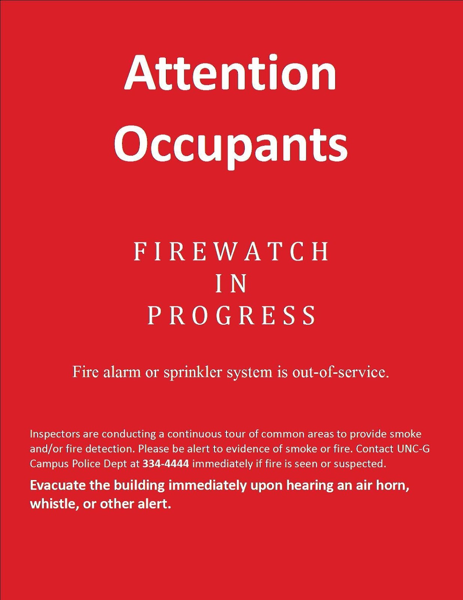

4.4 UNCG Environmental, Health, and Safety (EHS) Impairment Notification Form
(see https://safety.uncg.edu/resources/forms-reports-links/)

Fire Protection Impairment Notification Form - Appendix A
jasoter@uncg.edu Switch account

* Indicates required question
Email*
Record jasoter@uncg.edu as the email to be included with my response
What building(s) will be impacted by the impairment?*
Your answer
Is this a pre-planned impairment or emergency impairment?*
Choose
Will the impairment last more than 24 hours?*
If yes, then State Construction Office shall be consulted.
Choose

  - Fire System Impairment Tag:

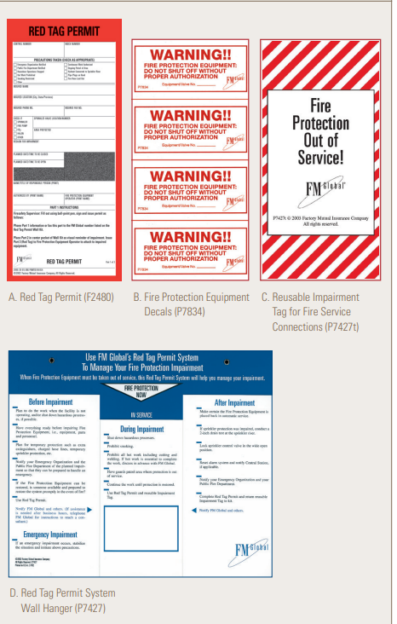

- Revision Table

Revision # | Section # | Summary of Changes | Approval Date
N/A | N/A | N/A | N/A

